Report

Title
Application: Large-Scale Image Merge System Using the Substitution Method

Aim
To solve the recurrence relation T(n) = T(n/2) + n using the Substitution Method and analyze its time complexity for a large-scale image merge system.

Objective
- To understand recursive image processing algorithms.
- To solve the given recurrence relation using the Substitution Method.
- To determine the asymptotic time complexity.
- To analyze the algorithm’s performance for large image datasets.

Software Requirements
- Python 3.x
- Visual Studio Code / PyCharm / IDLE

Theory
In image processing, large image datasets are often divided into smaller parts to simplify processing. The given recurrence relation represents an algorithm that divides the image into two equal halves recursively while performing linear work at each recursive level.
The recurrence relation is:
T(n) = T(n/2) + n
The Substitution Method solves the recurrence by repeatedly expanding it until the base case is reached.

Algorithm
- Start with the recurrence relation T(n) = T(n/2) + n.
- Expand the recurrence recursively.
- Continue expansion until the subproblem size becomes 1.
- Sum the work performed at each recursive level.
- Simplify the expression.
- Determine the asymptotic time complexity.

Source Code

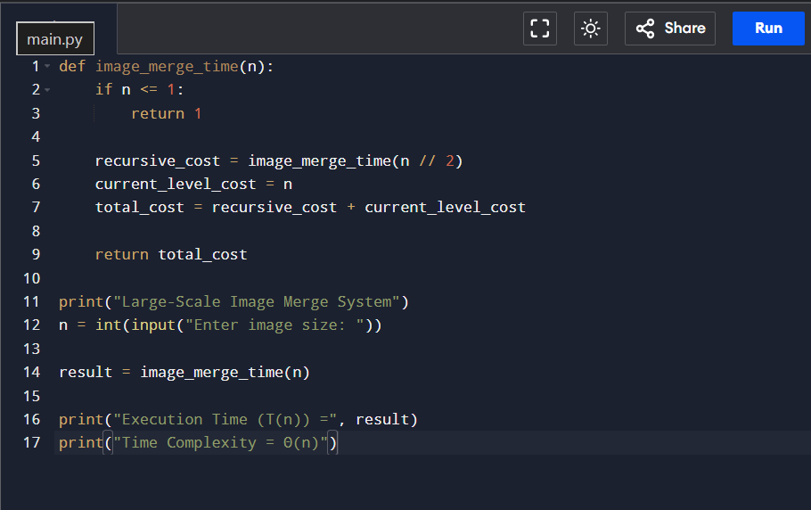Output

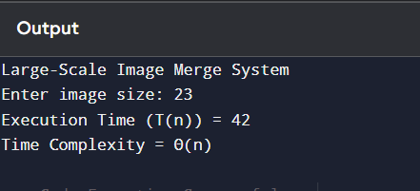

Analysis
Given,
T(n) = T(n/2) + n
Expand recursively:
T(n) = T(n/2) + n
= T(n/4) + n/2 + n
= T(n/8) + n/4 + n/2 + n
After k expansions,
T(n) = T(n/2ᵏ) + n(1 + 1/2 + 1/4 + …)
When n/2ᵏ = 1,
2ᵏ = n
k = log₂n
The geometric series converges to 2.
Therefore,
T(n) = T(1) + 2n
Ignoring constants,
T(n) = Θ(n)

Complexity Analysis
- Time Complexity: Θ(n)
- Space Complexity: Θ(log n) (recursive call stack)

Result
The recurrence relation T(n) = T(n/2) + n is solved using the Substitution Method. The algorithm has a linear time complexity Θ(n), making it efficient for processing large image datasets because the total work increases proportionally with the input size.

Title
Application: Image Processing System Using the Master Theorem

Aim
To solve the recurrence relation T(n) = 4T(n/2) + n using the Master Theorem and determine its time complexity.

Objective
- To apply the Master Theorem to recursive algorithms.
- To identify the values of a, b, and f(n).
- To determine the correct Master Theorem case.
- To analyze the performance of the algorithm as image size increases.

Software Requirements
- Python 3.x
- Visual Studio Code / PyCharm / IDLE

Theory
Many image processing algorithms divide an image into several smaller images and solve each recursively. The given recurrence relation represents an algorithm that divides the image into four recursive subproblems while performing additional linear work.
The recurrence relation is:
T(n) = 4T(n/2) + n
The Master Theorem provides a direct method for finding the asymptotic complexity of divide-and-conquer algorithms.

Algorithm
- Write the recurrence relation.
- Compare it with the standard Master Theorem form.
- Identify the values of a, b, and f(n).
- Calculate n^(log_b a).
- Compare f(n) with n^(log_b a).
- Select the appropriate Master Theorem case.
- Determine the final time complexity.

Source Code

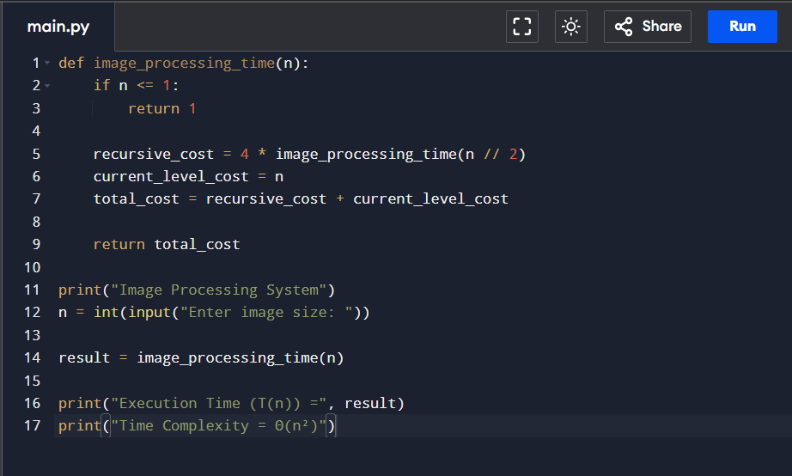Output

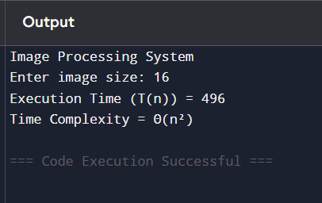

Analysis
Given,
T(n) = 4T(n/2) + n
Compare with
T(n) = aT(n/b) + f(n)
Where,
a = 4
b = 2
f(n) = n
Calculate,
n^(log₂4)
= n²
Since,
f(n) = O(n²⁻¹)
the recurrence satisfies Master Theorem Case 1.
Therefore,
T(n) = Θ(n²)

Complexity Analysis
- Time Complexity: Θ(n²)
- Space Complexity: Θ(log n) (recursive call stack)

Result
Using the Master Theorem, the recurrence relation T(n) = 4T(n/2) + n belongs to Case 1, giving the final complexity Θ(n²). The running time grows quadratically with the image size because the recursive calls dominate the overall computation.

